September 2021

**Clearwater Intermediate School Mission:**

“Clearwater Intermediate School staff will teach life skills emphasizing hands on activities, use of technology and building positive relationships"

Upcoming

Events

Thursday, Sept. 9

*Title I Annual Back to School Meeting (Virtual)

Monday, Sept. 20th – 24th

*Say Something Week

Tuesday, Oct. 5th

* Student Picture Day

Thursday, Oct 7

*End of 1st Quarter

Dear Parents,

It is hard to believe that we have already been in school for over 4 weeks! Our students have come in ready to learn and we have settled into the daily routines. Please remember that **you play a vital role in your child’s success at school**. You can help by asking your child about his/her day, having a positive attitude about learning, and reading to or with your child every night. You would be amazed what 20 minutes of reading with your child each night will do her his/her language development and reading skills. Thank you for all your support at home!

Tonya Mitchell, Principal



Principal's Newsletter

Clearwater Intermediate

Thank you for your efforts to get your children to school on time each day!

If your student needs to eat breakfast at school, please make arrangements for him/her to arrive **before 9:20**. This will allow time for eating breakfast and getting to class on time.

**Our school day starts at 9:40** and instruction begins right away. Students who are late arrivals miss valuable learning.





We need you!

We need you on our SAC! This is an excellent way to work with our teachers and administration to provide the very best for our children! If you are interested, please stop by the office or call the school and we will gladly give you information.



***PBIS Update***

We have been working with our Positive Behavior Interventions & Support (PBIS) lessons to ensure safe, responsible and respectful learners. Whether we are in the classroom, in the halls, in the cafeteria, outside, or in another area of the school, we have spent time reviewing our school’s expectations and how it should look and sound to be appropriate in our school. We know when students are not feeling safe, no learning can occur. In an effort to reward students, teachers have been handing out PBIS points when they see a student demonstrating safe, respectful and/or responsible behaviors. Students will be recognized for being safe, respectful and responsible in our school.

Below is information about our School Store which allows students to purchase privileges and/or items with their earned PBIS points. Be on the look-out!

Be sure to ask your child or children how they are being safe, respectful and responsible at school. Thank you for your help in keeping our students safe at school!



Panther School Store

We have an exciting new opportunity for our Panthers at the School store. We have begun offering a Panther Store for students as a way to “spend” PBIS points. Students will have a chance to shop in cafeteria on Tuesdays and Thursdays. During these shopping events, students can use their saved points to purchase special privileges.

Currently, students receive PBIS points for displaying appropriate behaviors in various settings. Obviously, the more frequently a student is doing what is expected, the more points he/she will earn. A student will save points until he/she has the number needed for the desired privilege/item. Look at what students can purchase!

CIS T-Shirt

Football, Water bottle, Eraser pack, Mechanical pencils, Stapler

Stress balls, Bracelets, Composition books, Cosmetic bags, Earrings, Games, Toys

Beads, Folders, Gift boxes, Highlighters, Key chains, Pencil sharpener, Pens, Sticky notepads, Tissue, Wrist band, Lunch with a teacher



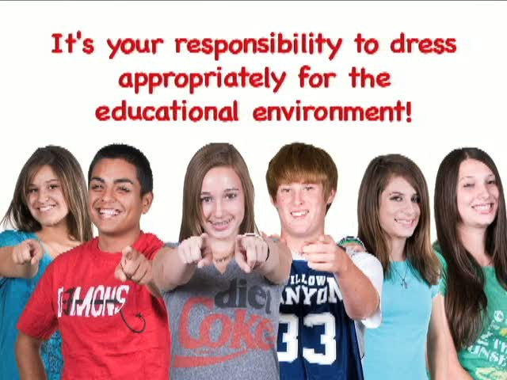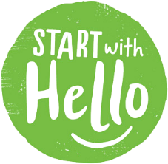

**Dress Code reminder . . .**

**Tops:**

White, red, grey, black or navy blue shirts with collars such as a polo, oxford, or dress shirt **(Shirts must have a collar)**

Students will be allowed to wear school-sponsored T-shirts on Fridays or school spirit days

Shirts must overlap the top portion of lower garments or bottoms (No exposed midriff)

**NO HOODS (Tops or Jackets)**

**Bottoms:**

Khaki, Black, or Navy pants, walking shorts, slacks, skirt, skorts, or jumpers

All items work at the waist (belts when needed)

All bottoms must be knee length or longer

No torn, baggy, form fitting clothing allowed

**NO Jeans**

**Shoes:**

Remain consistent with PCSB Student Code of Conduct

No flip flops/slides

**Backpacks**:

No Backpacks

The way we talk to our children becomes their inner voice.

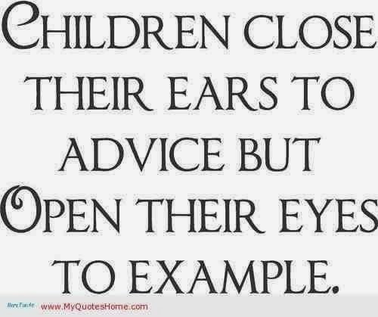

SANDY HOOK PROMISE

Start With Hello Week: September 20-24, 2021

**Start With Hello Week raises awareness about social isolation and educates students and the community on how to prevent it.**

**School Activities:**

**Monday Hay Day**

Encourage students greet each other by name

**Tuesday Random Acts of Kindness**

Randomly showing kindness

**Wednesday Green out**

Students wear green ribbons in honor of the lives lost at Sandy Hook.

It is the color of Sandy Hook School and Mental Health Awareness.

**Thursday Compliment Day**

Students give a teacher/staff member or classmate a sincere compliment

.

**Friday Signing Proclamation**

Students sign the Sandy Hook Promise Proclamation

**Homework Tips for Parents**

**1. Make sure your child has a quiet, well-lit place to do homework.**

Avoid having your child do homework with the television on or in places with other distractions, such as people

coming and going.

**2. Make sure the materials your child needs, such as paper, pencils, and a dictionary, are available.**

Ask your child if special materials will be needed for some projects, and get them in advance.

**3. Help your child with time management.**

Establish a set time each day for doing homework. Don't let your child leave homework until just before

bedtime. Think about using a weekend morning or afternoon for working on big projects, especially if the

project involves getting together with classmates.

**4. Be positive about homework.**

Tell your child how important school is. The attitude you express about homework will be the attitude your

child acquires.

**5. When your child does homework, you do homework.**

Show your child that the skills they are learning are related to things you do as an adult. If your child is

reading, you read too. If your child is doing math, balance your checkbook.

**6. When your child asks for help, provide guidance, not answers.**

Giving answers means your child will not learn the material. Too much help teaches your child that when

the going gets rough, someone will do the work for him or her.

**7. Stay informed.**

Talk with your child's teacher. Make sure you know the purpose of homework and your child's class rules.

**8. Help your child figure out what is hard homework and what is easy homework.**

Have your child do the hard work first. This will mean he will be most alert when facing the biggest challenges.

Easy material will seem to go fast when fatigue begins to set in.

**9. Watch your child for signs of failure and frustration.**

Let your child take a short break if she is having trouble keeping her mind on an assignment.

**10. Reward progress in homework.**

If your child has been successful in homework completion and is working hard, celebrate that success with

a special event (e.g., pizza, a walk, a trip to the park) to reinforce the positive effort.

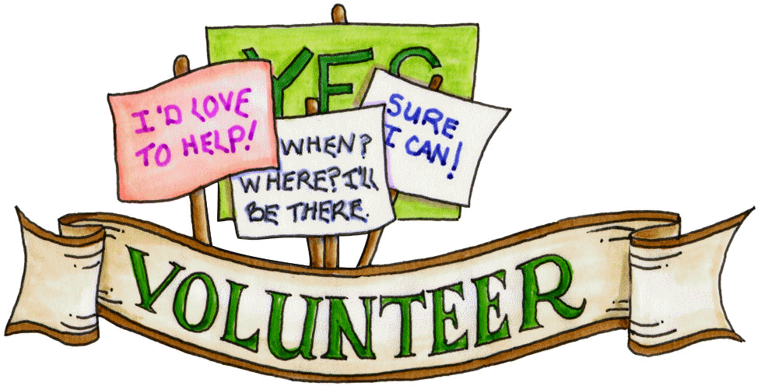

Believe in yourself. As a parent, you are a child’s best therapist and advocate.

***Safety is priority***

Please make sure your child wears tennis shoes on Physical Education days. Shoes can make a big difference in the safety of your child and his/her classmates.

There is no such thing as a perfect parent

So just be a real one.

Sue Atkins

Calling Volunteers!!

Want to become a more integral part of our school community? Volunteer!

Please consider volunteering at our school. Below are some ways to do so:

*Tutor

*Mentor

*Activities Volunteer

*Great American Teach In

We hope that you will consider volunteering at our school in some way. Volunteer registration forms are available in the front office.

Clearwater Intermediate School and Title I present:



-and-

An Explanation of Title 1 Benefits and Family Engagement

Enjoy dinner and celebrate a new school year!

*Thursday, September 9, 2021*

*5:30 p.m. (Virtual)*